Enquiry based learning planner
This planner has been created to provide a focus for discussion in the design and development of new courses and individual modules/learning activities. It can also be used to aid reflection on existing courses and modules. It is based upon learning design research (AUTC, 2003; Oliver, 1999; Kahn & O’Rourke, 2004; and Reeves & Reeves, 1997) and provides a means of recording and communicating discussions on curriculum developments; recording the results of conversations.

The planner consists of three elements. These can be used together or the individual elements used for a specific purpose.

 | Course Development | Course Review | Module Development | Module Review
- A checklist that encourages a focus on enquiry based learning approaches, against which to discuss and outline choices in your planned development. This can be used at different levels, with the course as whole or for single modules.

- A list of principles of good learning design, these act as an aide-memoire for reflecting on developments, course or module, as a whole
- A temporal plan, which is best used at the module/learning activity level. Completing this plan provides a means of representing the learning activities, resources and supports required for a module or learning activity and the inter-relationships between them.

Space is provided at the end to record module information.

Check list
Use this checklist to reflect on your course/module/learning activity. This list has been informed by Boud & Prosser (2003), Kahn & O’Rourke (2004) and Reeves & Reeves (1997). Active engagement is at the core of these questions.

Checklist Checklist

Course Design

1.1 Learner empowerment

To what extent are students encouraged to take greater responsibility for their learning as they progress through their learning (Scaffolding)?

Not at all ---------------------- to some extent -------------------------- To a great extent

Comment:

1.2 Peer collaboration

To what extent are students provided with opportunities for working within learning communities through collaborative learning and peer interaction?

Not at all ---------------------- to some extent -------------------------- To a great extent

Comment:

1. 3 Feedback

Are students provided with regular opportunities to receive feedback (Tutor and peer)?

Not at all ---------------------- to some extent -------------------------- To a great extent

Comment:

1.4 Delivery

To what extent is flexibility in delivery allowed?

Not at all ---------------------- to some extent -------------------------- To a great extent

Comment:

1.5 Inclusion

Checklist Checklist

To what extent does the design and delivery show awareness of diversity and cultural issues and students individual learning needs?

Not at all ---------------------- to some extent -------------------------- To a great extent

Comment:

Learning Context

2.1 Reflection

Are students provided with opportunities for reflection, both individual and social (public)?

Not at all ---------------------- to some extent -------------------------- To a great extent

Comment:

2.2 Authenticity

To what extent do the nature of the student activities have an authentic focus?

Not at all ---------------------- to some extent -------------------------- To a great extent

Comment:

Challenging Learners

3.1 Complexity

Are students engaged in complex, unstructured problems?

Not at all ---------------------- to some extent -------------------------- To a great extent

Comment:

3.2 Exploration

Checklist Checklist

Are students stimulated to seek and explore new information and knowledge?

Not at all ---------------------- to some extent -------------------------- To a great extent

Comment:

Providing practice

4.1 Articulation

To what extent are students provided with opportunities to articulate their learning (to self and others)?

Not at all ---------------------- to some extent -------------------------- To a great extent

Comment:

References
Academic Practice and Organisational Development, web site, University of Birmingham http://www.hr.bham.ac.uk/development/index.shtml

AUTC (2003) Learning designs, http://www.learningdesigns.uow.edu.au/index.html

Boud, D & Prosser, M (2002) Appraising new technologies for learning: a framework for development, Education Media International, 39(3) pp237-245

Joint Information Systems Committee 9JISC) (2004) Effective practice with e-learning. A good practice guide in designing for learning. HEFCE

Kahn, P. & O’Rourke, K. (2004) Guide to curriculum design: enquiry based learning, HEA

Oliver, R. (1999). Exploring strategies for on-line teaching and learning. Distance Education, 20(2), 240-254.

Oliver, R. (2001). Seeking best practice in online learning: Flexible Learning Toolboxes in the Australian VET sector. Australian Journal of Educational Technology, 17(2), 204-222.

Oliver, R. & Herrington, J. (2001). Teaching and learning online: A beginner’s guide to e-learning and e-teaching in higher education. Edith Cowan University: Western Australia.

Reeves, T.C. & Reeves, P.M. (1997) Effective dimensions of interactive learning on the world wide web, in Khan, B.D. (Ed) Web-based instruction. Englewood Cliffs: Educational Technology Publications pp 59-66

Principles of good design

Principles of good design
Purpose: these principles provide a consistent framework for reflection and analysis, this framework is not value neutral and assumes a constructivist approach. Its purpose is to help encourage reflection on the learning activities used and how students are supported and engaged. The framework can be used at all levels of students activity and so it must be emphasised that not all the prompts will be relevant in all cases.

1 CHALLENGING LEARNERS

- How does the course/module/learning activity encourage/motivate students in going beyond the knowledge/resources provided for them?
- How is module/learning activity integrated into future modules?
- How are students encouraged to be self-critical and test their own knowledge and assumptions at various points? Are opportunities for public reflection provided?

2 THE LEARNING CONTEXT

- In what ways are problems, issues and activities situated for the student using authentic examples
- What support is provided and in what form? [resources used/required including other staff]
- How does the module/learning activity help students to see how the current learning can be transferred to other contexts and situations beyond the ones given?
- What scaffolding is provided to help equip students with the demands of the module/learning activity?
- How is student assessment aligned with the learning outcomes and chosen tasks?

3 PROVIDING PRACTICE
- How do students articulate and demonstrate to themselves and others what they are learning?
- How will students use the feedback provided?
- How does the module/learning activity equip students to apply assessment criteria to be sure they are learning appropriately?
- Are learners provided with examples of the kind of work expected of them?

4 COURSE DESIGN & PLANNING

- What support is in place for skills development?
- How does the module/learning activity take account of different learning styles in its delivery?
- What opportunities does the module/learning activity provide for students to engage with their peers and gain feedback from them? (e.g. group work, peer assessmen
- How is formative and summative assessment used to facilitate student engagement?
- In what ways does the module/learning activity enable learners to reflect on their learning activities? Are reflections private or social?
- How does the module/learning activity engage with students as individuals? (affective support)
- How is flexibility of delivery provided?

Boud, D & Prosser, M (2002) Appraising new technologies for learning: a framework for development, Education Media International, 39(3) pp237-245

Temporal Plan
The basis for this temporal plan is informed by the work of Oliver (1999, 2001) and Oliver and Herrington (2001). This identifies the key elements of a learning design as:

Temporal plan Temporal plan
- learning activities: The learning activities are represented by a series of rectangles, arranged vertically. These activities represent the learner’s "journey". Each rectangle has a description of what the learners are required to do or produce. Activities that are assessable are distinguished with an asterisk (*).
- learning resources: Learning resources are represented by triangles to the left of the activity sequence. An arrow from a resource (triangle) to an activity (square) indicates that resources are available to the student when doing the activity. An arrow from an activity (square) to a resource (triangle) indicates that a resource is produced during the activity and becomes a resource for others to use later.
- learning supports: The learning supports are represented by circles to the right of the activity sequence. An arrow from a "circle" to a "square" indicates that support strategies are being used to assist the students in their learning.

Resources | Learning activities | Supports

Look at the following example before starting your own plan.

Example Temporal Plans

Temporal plan Temporal plan
Representation of learning activity designed for Biology & Psychology Students as part of their induction to University (University of Gloucestershire)

Resources Learning Activities Supports

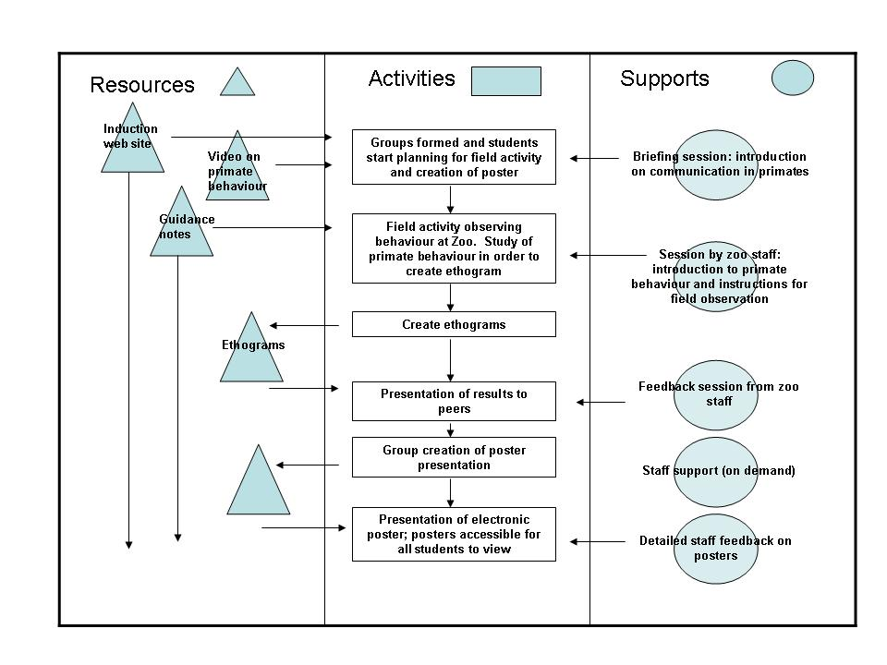

Example Temporal plan taken from the Learning Designs project web site (http://www.learningdesigns.uow.edu.au/project/learn_design.htm)

Temporal plan Temporal plan

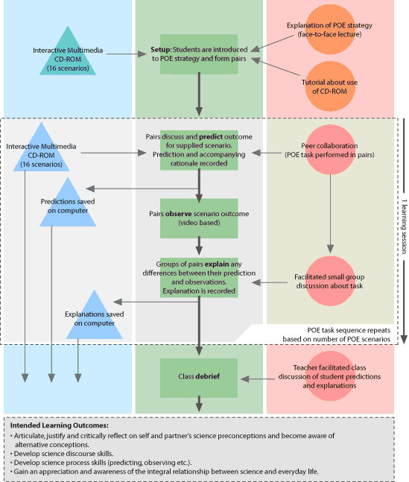

Module information
Module name and number

Module information
Learning outcomes. | Knowledge and Understanding  Skills
Anticipated student numbers
Assessment details

